Task 1 – Create IAM User and Group
- Launch two EC2 instance.
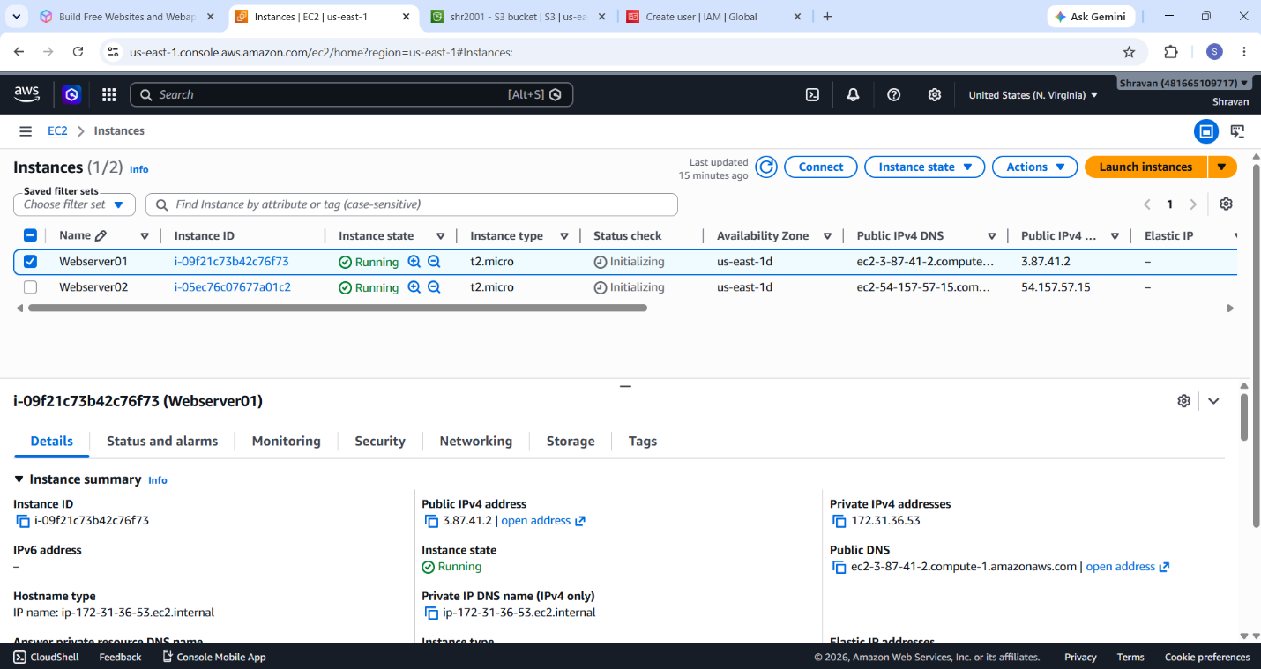

- Launch S3 Bucket.
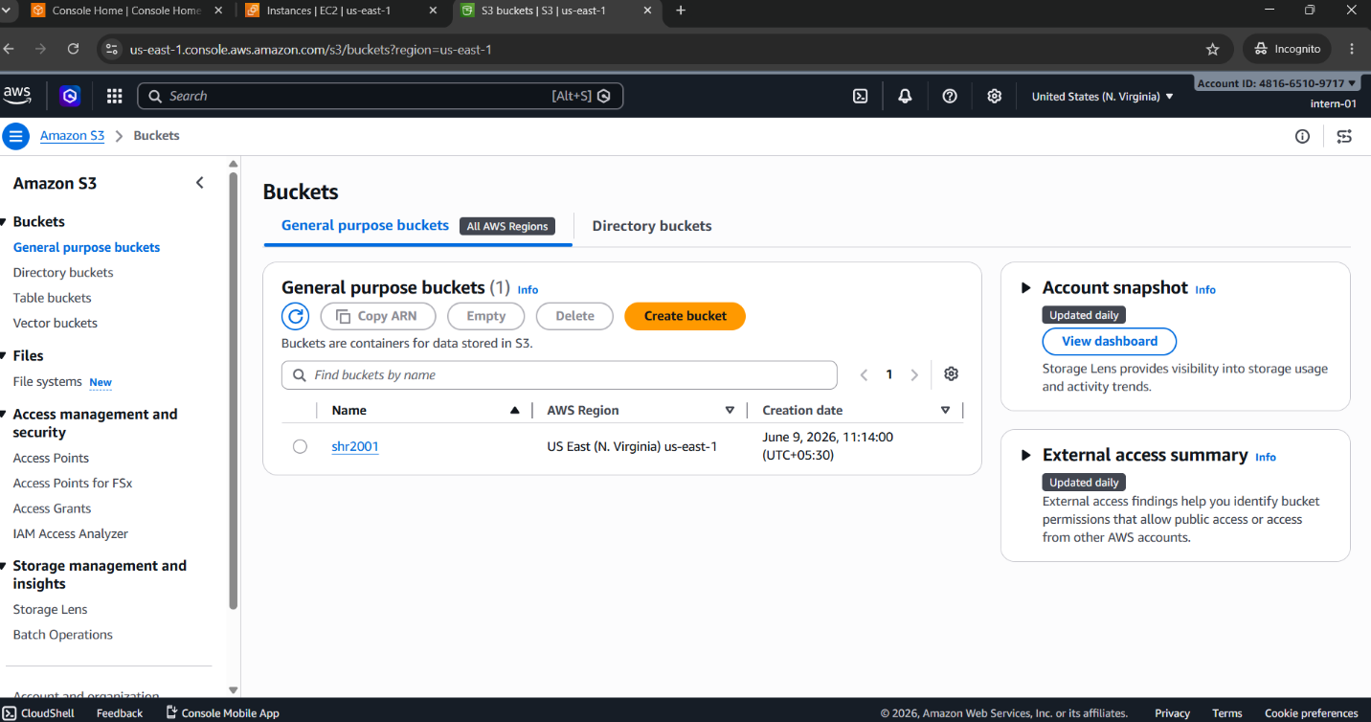

Task 1 – Create IAM User and Group
- Scenario: Create a new user account for an intern.
- Create:
- Group: Interns
- User: intern-01
- Add the user to the group.
- Deliverables: Screenshots showing:
- IAM Dashboard, Group creation, User creation, Group membership

- Create User: intern-01
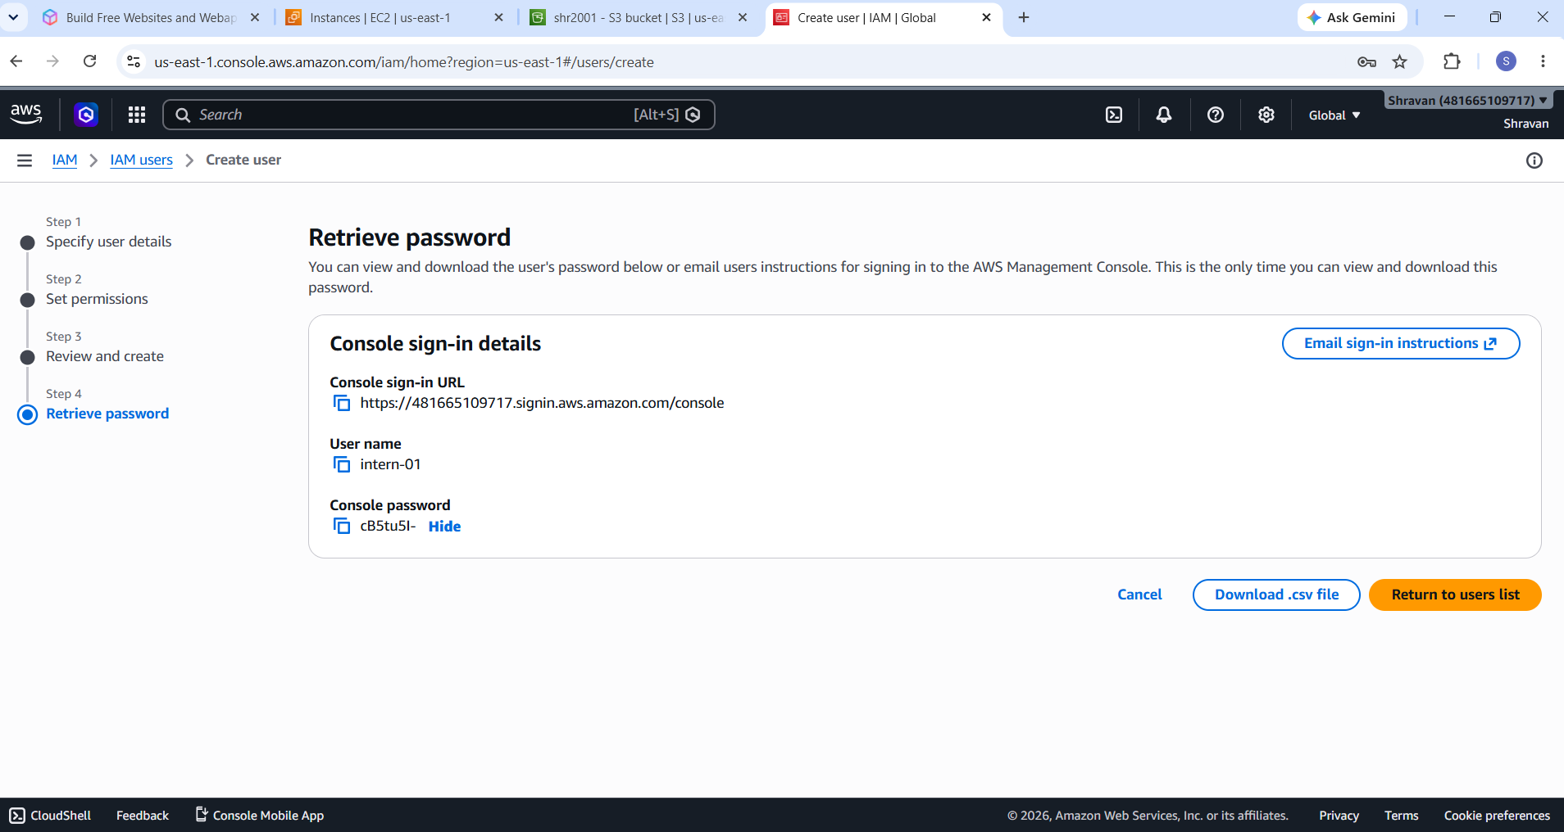

- Add the user to the group.
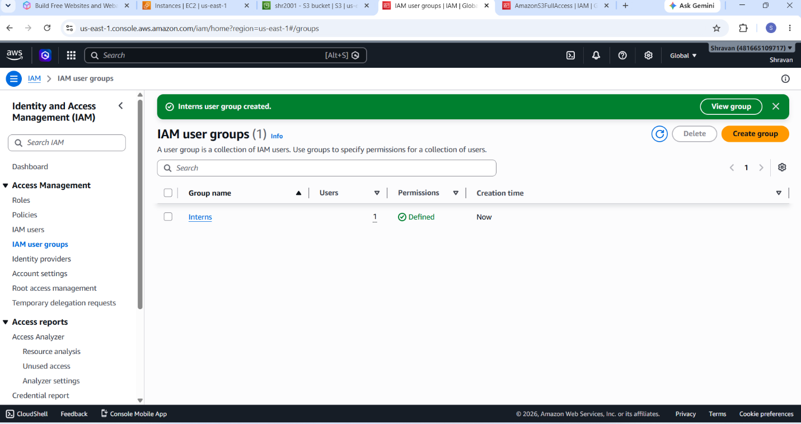
Task 2 – Assign Read-Only Access
- Scenario: The intern should only be able to view AWS resources.
- Requirements: Attach the AWS managed policy: ReadOnlyAccess to the Interns group.
- Deliverables: Screenshot showing: Attached ReadOnlyAccess policy

- Asssign the ReadOnlyAccess permission to the Interns group.

- 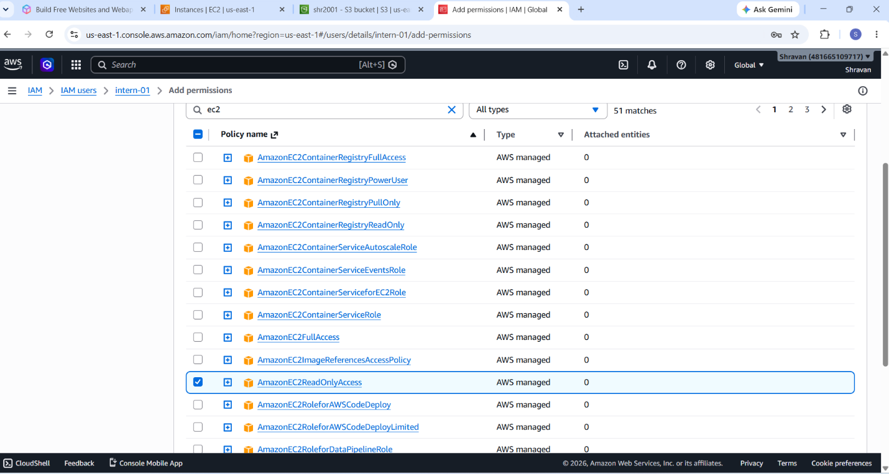

Task 3 – Create Custom S3 Read Policy
- Scenario: A team should only access a specific S3 bucket.
- Requirements:-
- Create a custom policy named: Intern-S3-ReadOnly
- Allow: s3:ListBucket, s3:GetObject
- For: intern-training-bucke
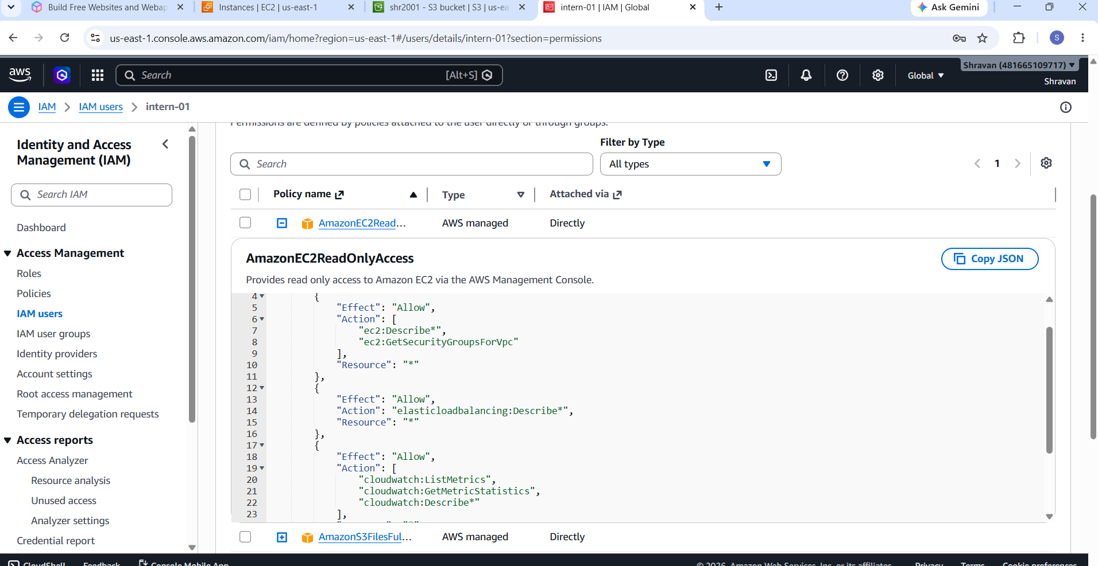

Task 5 – Create IAM Role for EC2
- Scenario: An EC2 instance needs access to S3 without using access keys.
- Requirements:
- Create Role: EC2-S3-ReadOnly
- Trusted Entity: EC2
- Permissions: AmazonS3ReadOnlyAccess
- Deliverables:
- Screenshots showing: Trust relationship, Attached permissions

- Create Role: EC2-S3-ReadOnly
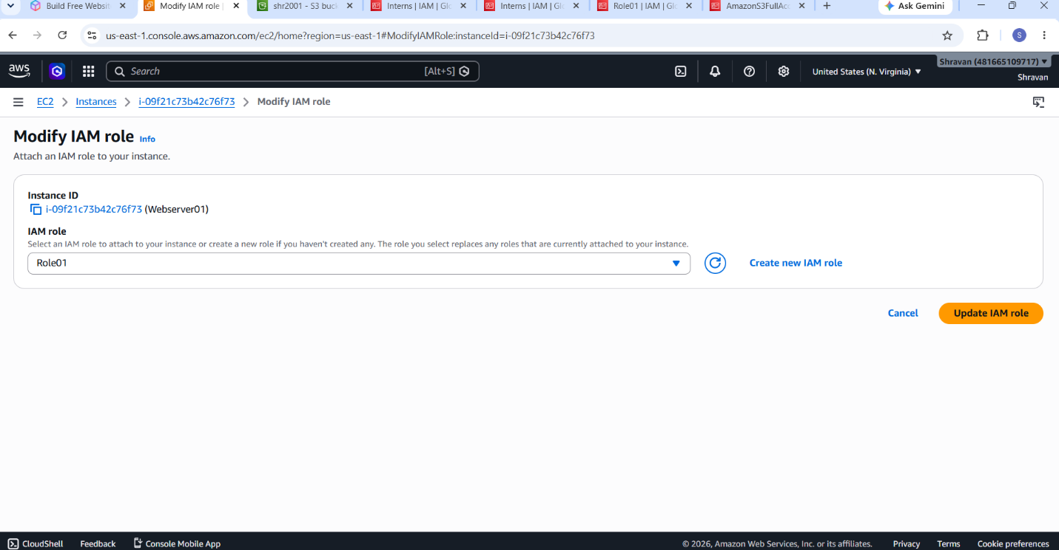

- Permissions: AmazonS3ReadOnlyAccess
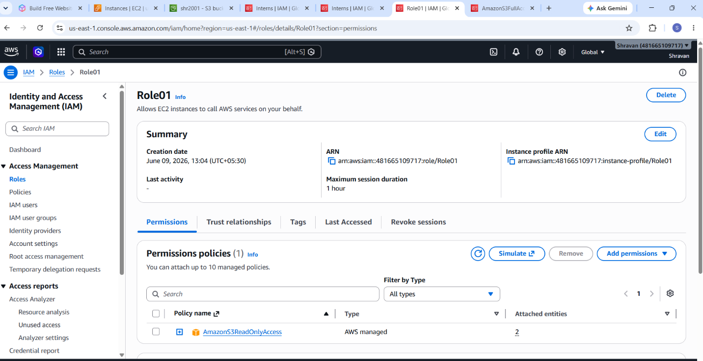

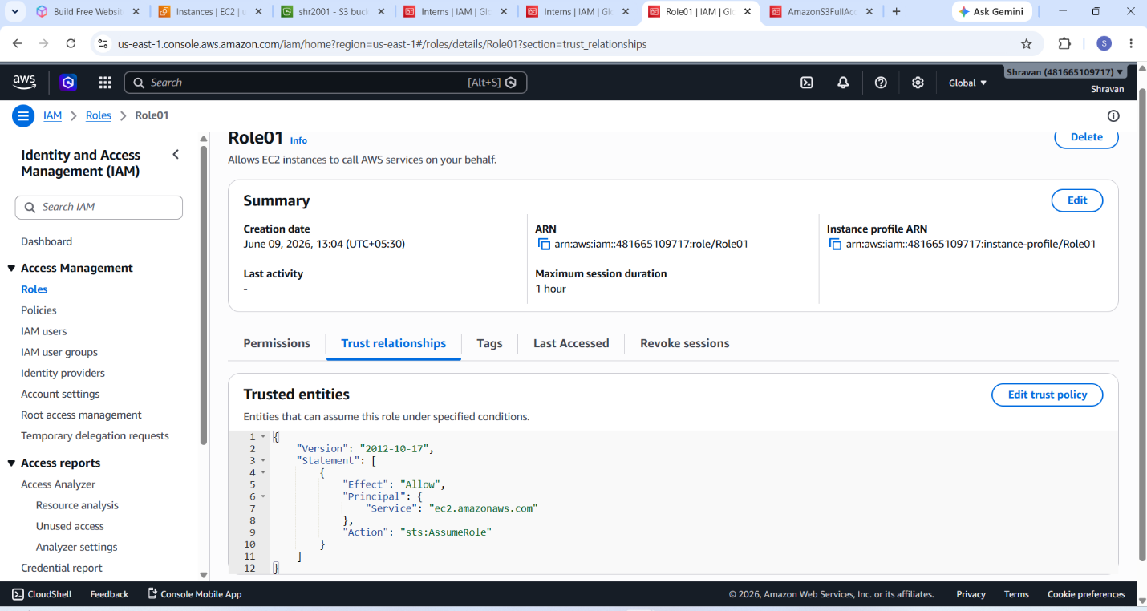

- An EC2 instance needs access to S3 without using access keys
